Selecting Teams & inputting scores in MyCricket
Link to Mycricket is below
https://mycricketadmin.cricket.com.au/login.aspx?sslredirect=1
In here you can select your team for the week as well as update the match results (home team responsibility) & input the batting and bowling figures for each player.
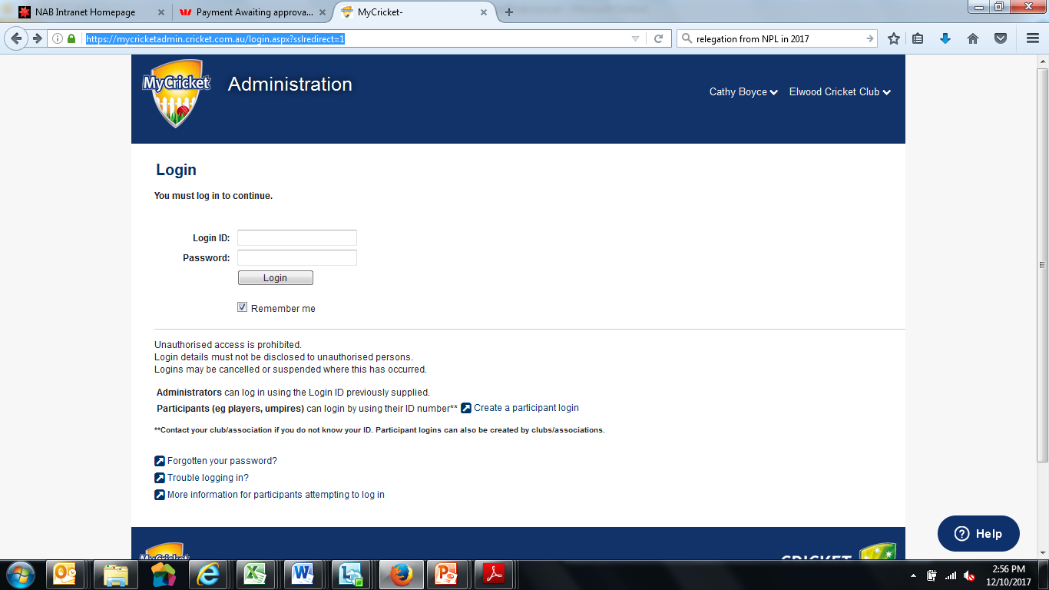

Selecting the Team:
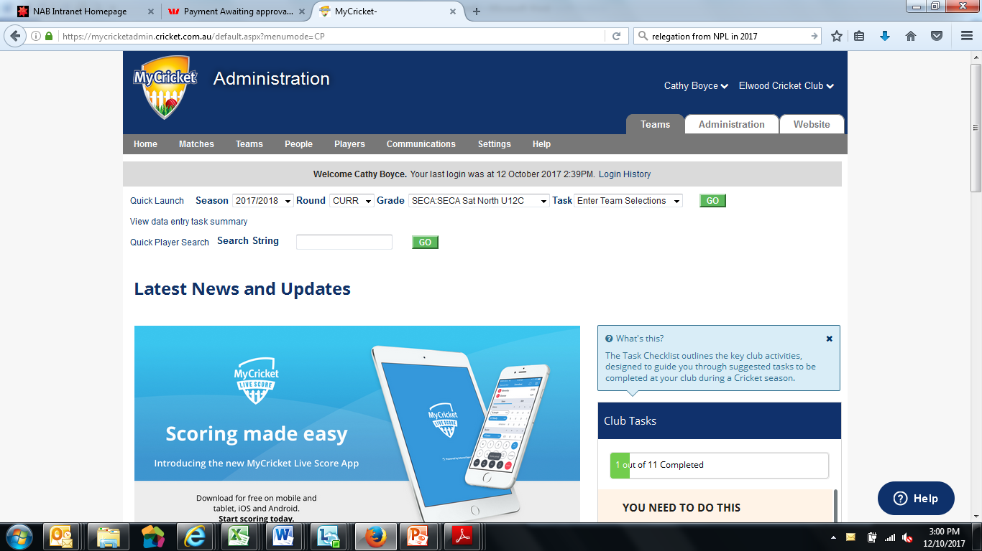
- Select the Team Tab
- Your team should appear as a default, if not select it from the Grade Dropdown
- Select the “Enter Team Selections” from the Task dropdown menu
- You will now see the screen below – to populate the selected players box just pick a player from the players list on the Left hand side and click on “Add” to bring them across.
- For ease of inputting scores, the order they appear in here should reflect your batting order .

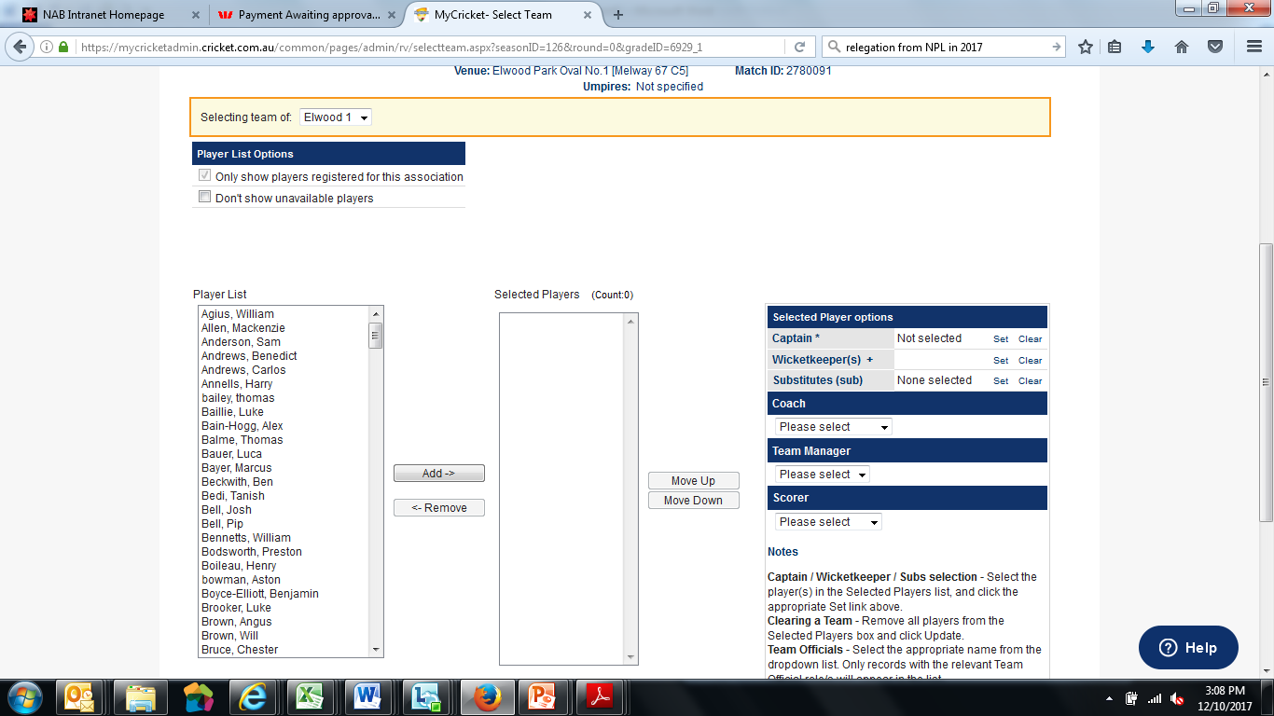

Inputting the Match Results:
From the Matches Drop down menu select “Enter Match Results”
When inputting individual batting & bowling stats then you will select “Enter Player Scores” from this menu
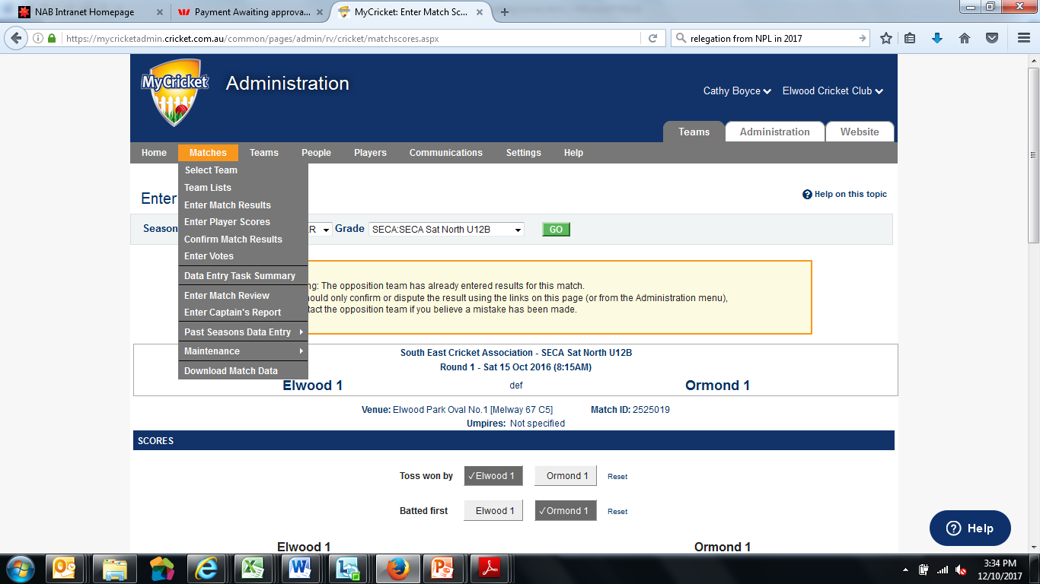
If you are the home team then you must input the match results by 9am on the Sunday after the game has finished, if it is a 2-day game you are not required to input the in-progress score after the first day.
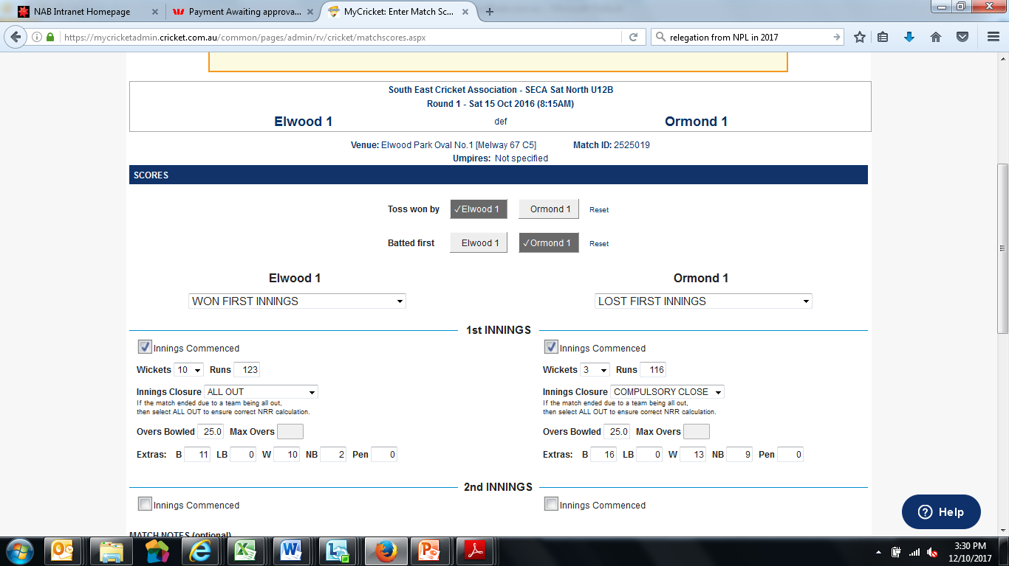
Note: the summary that goes in here is checked against the individual scores you put in for your batsmen & bowlers and for extras, there is an error tolerance but if it is outside this range then it won’t let you complete the individual scoring

Entering Individual Batting & Bowling Stats:

